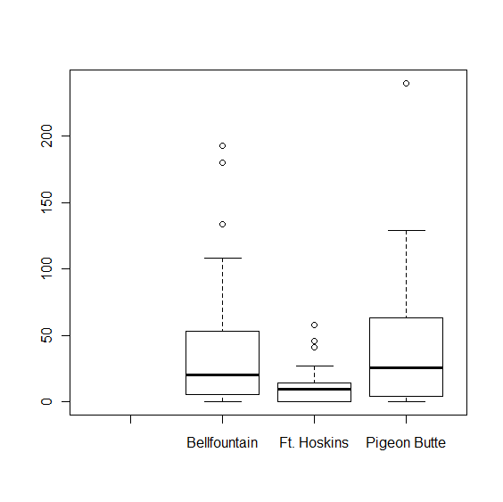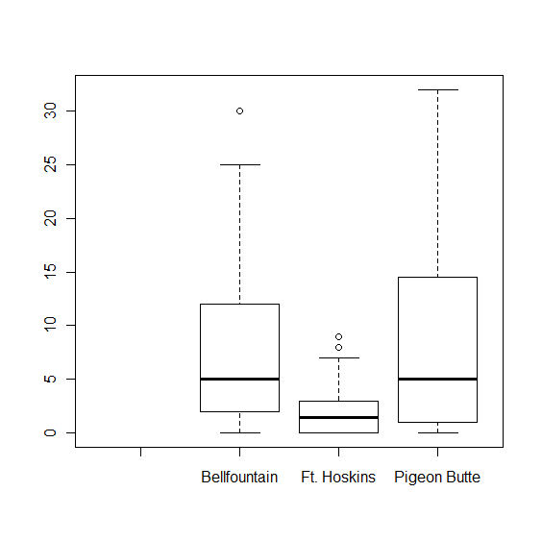

Site vs # plants

Site vs Leaves

> step1.lm<-lm(luor2011 ~ Site + Scarified + Moss + Litter + Bare +Disturbed)

> anova(step1.lm)

Analysis of Variance Table

Response: luor2011

Df Sum Sq Mean Sq F value Pr(>F)

Site 2 920.8 460.4 12.2570 1.565e-05 \*\*\*

Scarified 1 593.5 593.5 15.8012 0.0001262 \*\*\*

Moss 1 1.6 1.6 0.0423 0.8374978

Litter 1 13.2 13.2 0.3524 0.5539902

Bare 1 102.6 102.6 2.7315 0.1012373

Disturbed 1 812.2 812.2 21.6239 9.284e-06 \*\*\*

Residuals 110 4131.9 37.6

> summary(step1.lm)

Call:

lm(formula = luor2011 ~ Site + Scarified + Moss + Litter + Bare +

Disturbed)

Residuals:

Min 1Q Median 3Q Max

-9.91238 -4.63705 0.01797 2.89677 18.27256

Coefficients:

Estimate Std. Error t value Pr(>|t|)

(Intercept) 18.73334 2.56697 7.298 4.83e-11 \*\*\*

SiteFt. Hoskins -9.07842 1.75494 -5.173 1.04e-06 \*\*\*

SitePigeon Butte -1.70434 1.73839 -0.980 0.32904

Scarifiedy -4.68342 1.13662 -4.120 7.35e-05 \*\*\*

Moss -0.07528 0.03891 -1.934 0.05564 .

Litter -0.07196 0.02684 -2.681 0.00846 \*\*

Bare -0.30884 0.19752 -1.564 0.12079

Disturbed -0.29558 0.06356 -4.650 9.28e-06 \*\*\*

All sites

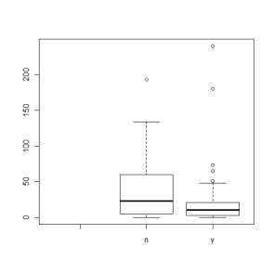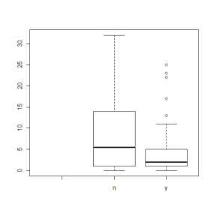

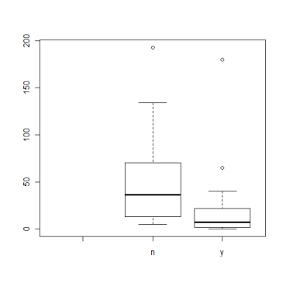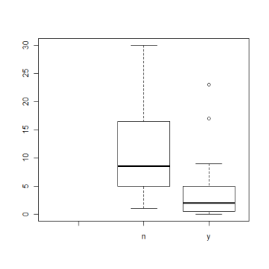Bellfountain

Ft. Hoskins

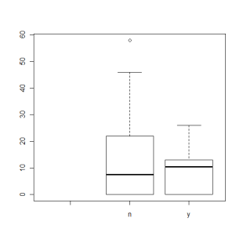Pigeon Butte

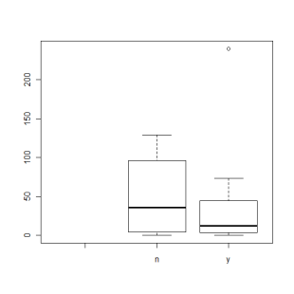

> summary(leaves.change.lm2)

Call:

lm(formula = leaves.change ~ Site + Scarified + Grass + Forb +

LD)

Residuals:

Min 1Q Median 3Q Max

-98.8284 -22.6083 -0.6501 19.7390 106.1932

Coefficients:

Estimate Std. Error t value Pr(>|t|)

(Intercept) -44.3204 18.2389 -2.430 0.01670 \*

SiteFt. Hoskins -42.3148 8.2250 -5.145 1.17e-06 \*\*\*

SitePigeon Butte -27.5465 9.4539 -2.914 0.00432 \*\*

Scarifiedy 15.5694 6.3864 2.438 0.01636 \*

Grass -0.3538 0.2459 -1.439 0.15292

Forb 0.5566 0.2270 2.452 0.01578 \*

LD 5.1426 2.5620 2.007 0.04715 \*

Analysis of Variance Table

Response: leaves.change

Df Sum Sq Mean Sq F value Pr(>F)

Site 2 21255 10628 8.4755 0.0003736 \*\*\*

Grass 1 13475 13475 10.7464 0.0013921 \*\*

Forb 1 6257 6257 4.9902 0.0274775 \*

LD 1 5026 5026 4.0085 0.0476871 \*

Residuals 112 140438 1254

> summary(leaves.change.lm2)

Call:

lm(formula = leaves.change ~ Site + Grass + Forb + LD)

Residuals:

Min 1Q Median 3Q Max

-105.774 -24.562 2.227 22.972 114.091

Coefficients:

Estimate Std. Error t value Pr(>|t|)

(Intercept) -35.7563 18.2882 -1.955 0.05306 .

SiteFt. Hoskins -42.8248 8.4019 -5.097 1.41e-06 \*\*\*

SitePigeon Butte -27.6472 9.6601 -2.862 0.00503 \*\*

Grass -0.3726 0.2511 -1.484 0.14061

Forb 0.5481 0.2320 2.363 0.01986 \*

LD 5.2408 2.6176 2.002 0.04769 \*

Multiple R-squared: 0.2468,

Tried ratio leaves/plants

& ratio change leaves2010/plants2010 – leaves2011/plants2011

R2 never over .15